## 1. Brandmower

Handycache permission must be sufficient!

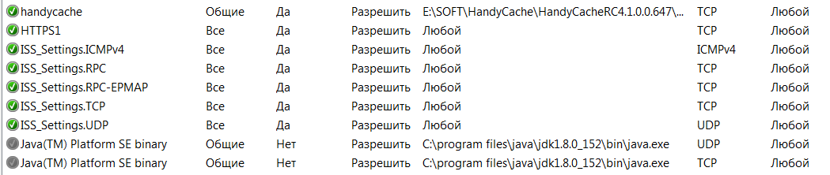

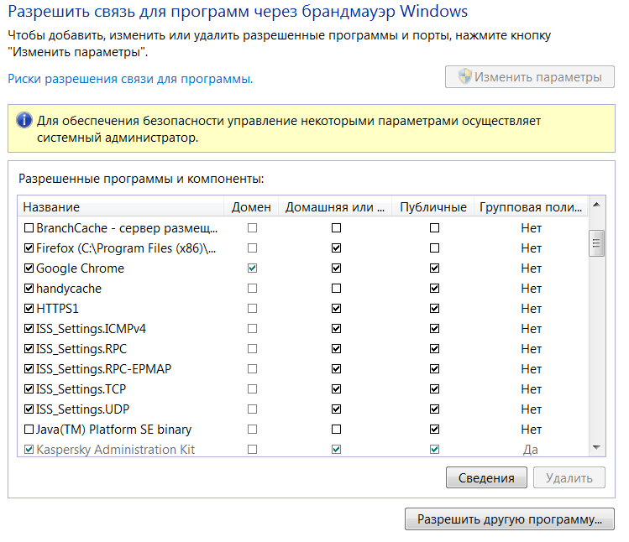

## 2. HandyCache Settings and Monitoring

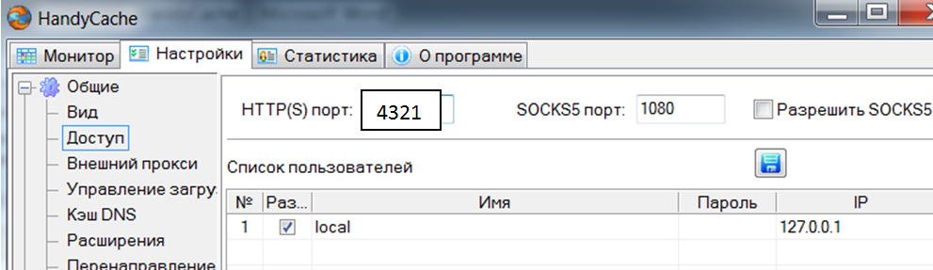

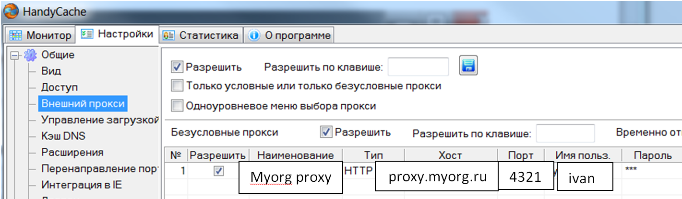

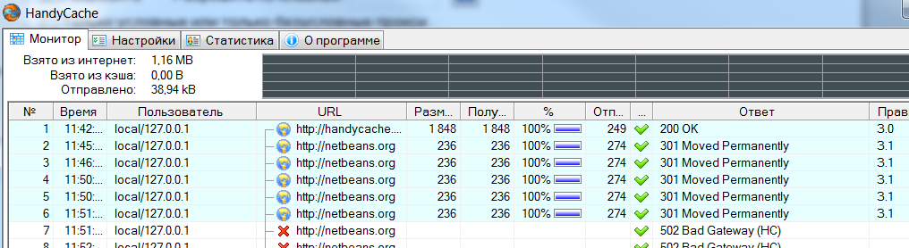

## 3. Java net.properties

### Location

jre_home/libs/net.properties

### Content

#

**java.net.useSystemProxies=false**

# HTTP Settings

**http.proxyHost=127.0.0.1**

**http.proxyPort=3128**

#test.soap-server.ru for wsdl getting

**http.nonProxyHosts=localhost|127.*|[::1]]| test.soap-server.ru**

# HTTPS Settings

**https.proxyHost=127.0.0.1**

**https.proxyPort=3128**

# ? Don’t know why

jdk.http.auth.tunneling.disabledSchemes=Basic

### How to check

#### 1. Using Netbeans

Use netbeans menu: tools -> option-> Test Connection.

**See HandyCache monitor!**

If 200 or 301 then OK.

#### 2. Using github repositories

(for http-https connections testing)

If socket error, then see https settings